Natural Language Processing:



7/11/2023

Documentation by

Vairavan M

**Natural Language Processing:**

Natural language processing (NLP) refers to the branch of computer science—and more specifically, the branch of artificial intelligence or AI—concerned with giving computers the ability to understand text and spoken words in much the same way human beings can.

**Applications of NLP:**

1).Sentiment Analysis: NLP can be used to analyse and determine the sentiment expressed in text, such as customer reviews, social media posts, or survey responses. It helps in understanding public opinion, customer satisfaction, and brand perception.

2).Text Classification: NLP enables text classification tasks, such as categorizing documents or emails into predefined categories, spam detection, news topic classification, or sentiment-based classification.

3).translation of text or speech from one language to another. Neural machine translation models using NLP have greatly improved translation accuracy.

**List of Libraries important for Sentiment Analysis.**

* NLTK
* TextBlob
* VADER,
* SpaCy,
* BERT,
* Flair,
* PyTorch,
* scikit-learn

Assignment Description:

Build a sentiment analysis classifier using natural language processing techniques. Use a labeled dataset of customer reviews, where each review is labeled as positive or negative. Implement and evaluate the classifier's performance, and provide insights into its potential real-world applications.

Solution:

Python code to implement the above performance using the libraries in NLP executed in Jupiter.

STEP 1:

**Dataset for the reviews:**

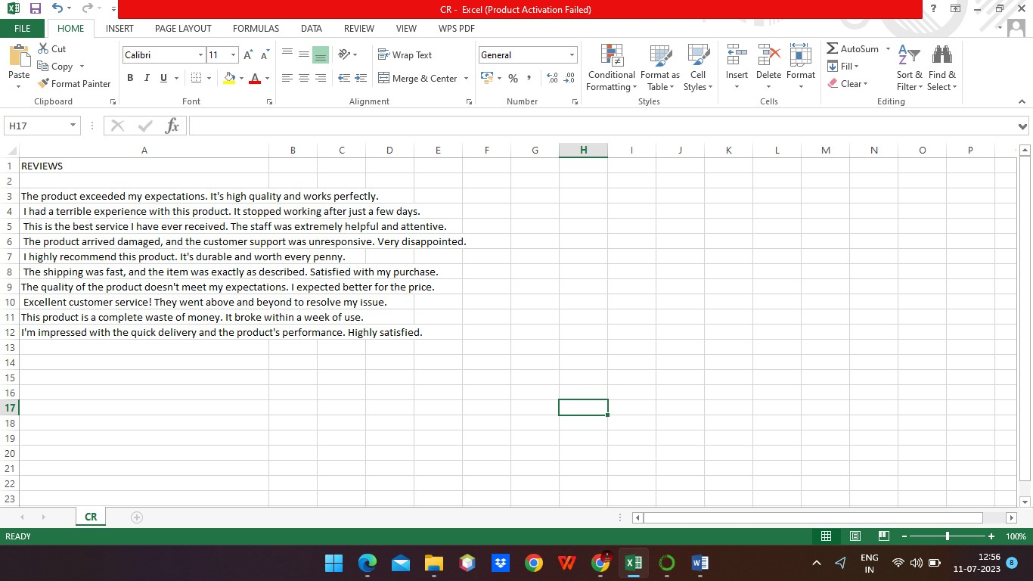

STEP 2:

Importing needed Libraries for the program:

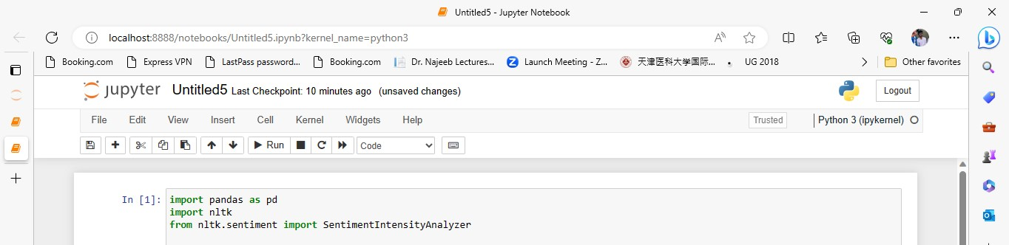

STEP 3:

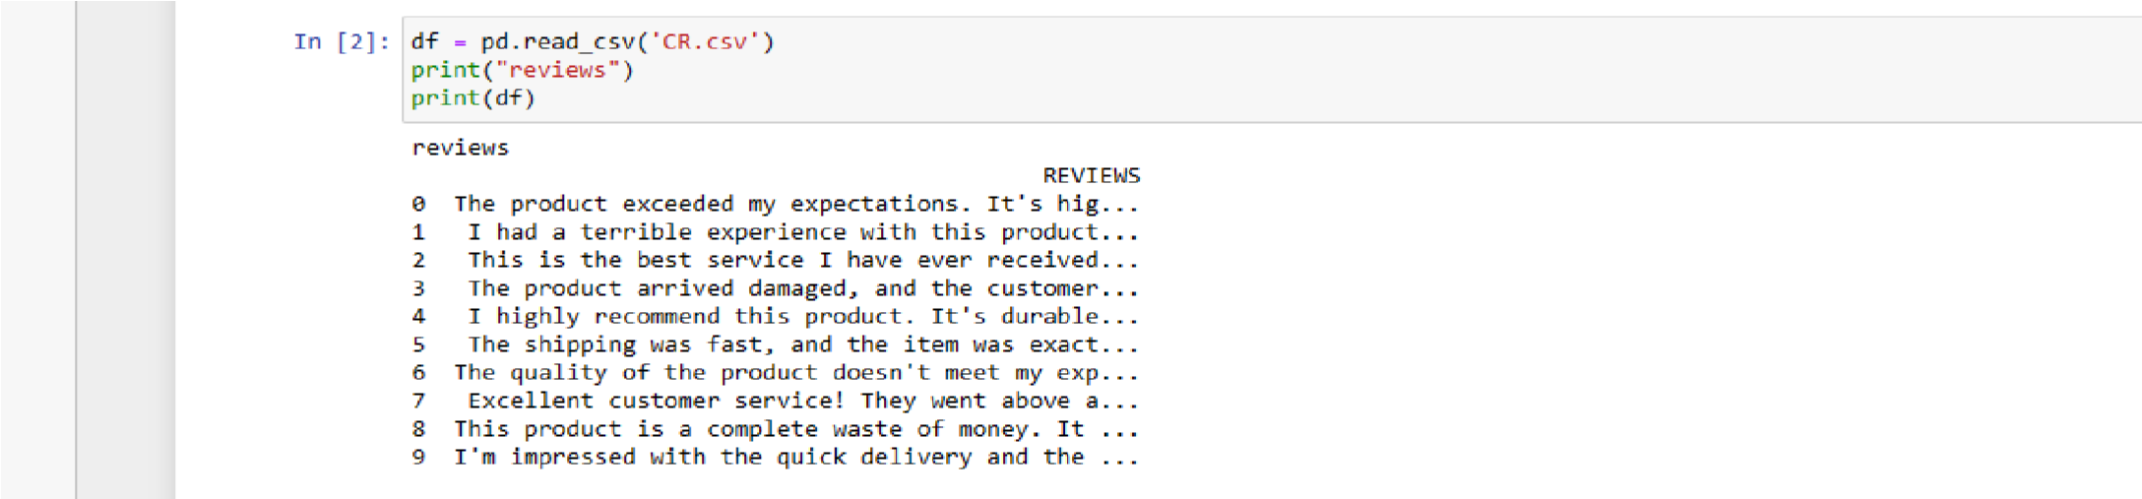Get the input dataset and display the reviews

STEP 4:

Get the column name



STEP 5:

Download the vader_lexicon



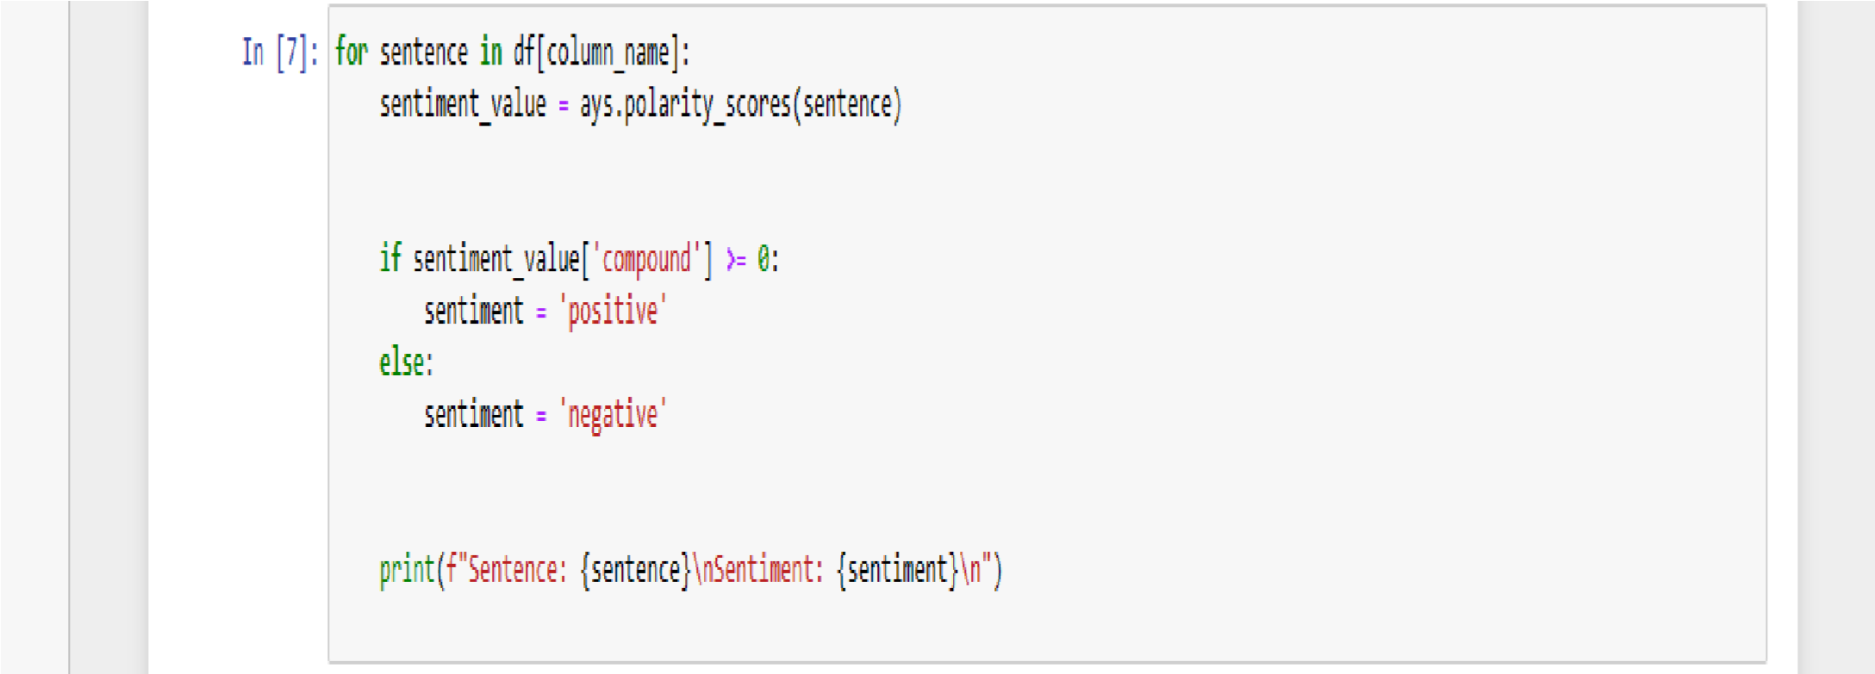The line nltk.download ('vader_lexicon') is used to download the VADER (Valence Aware Dictionary and sentiment Reasoner) lexicon from the NLTK (Natural Language Toolkit) library. The VADER lexicon is a pre-trained model specifically designed for sentiment analysis in text.

STEP 6:

Final for statement, if condition and print statement to get the final output

**OUTPUT:**

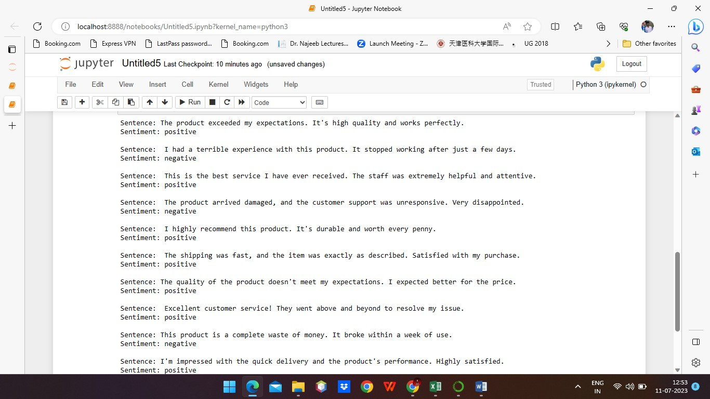

**Thank You**